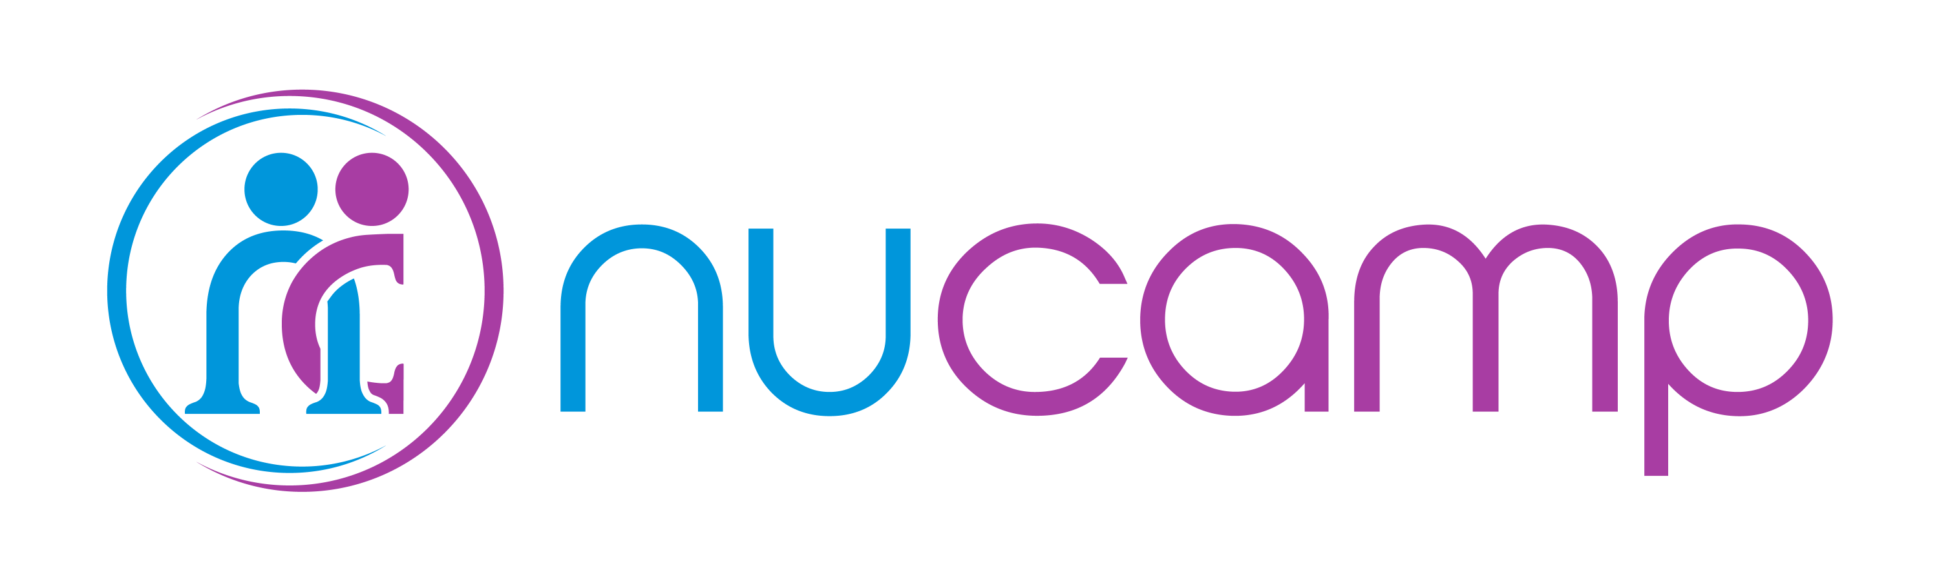

# Welcome to Nucamp Project Portfolio guidance document!

In the upcoming months you will be creating **two** **to three** **portfolio projects.**

We suggest creating:

1. one **Bootstrap** website and,
2. one **React** single-page-application,
3. and optionally one **React Native** mobile application.

Each project portfolio can leverage the same idea / concept and simply be “ported over” to the new dev JavaScript framework, meaning from Bootstrap to React to React Native.

Please refer to the general outline below to make sure that you are on track to complete your projects by the end of the program. The portfolio projects are your chance to apply these concepts, and you have the freedom to pick and choose which elements you want to include. Make something that you will be proud of!

|  |  |  |
| --- | --- | --- |
| **Week** | **Course** | **Roadmap** |
| 1 | **Bootstrap 0** | Set up your coding environment. |
| 2 | **Bootstrap 1** | Start brainstorming project ideas. This is also a good time to start getting comfortable with git. Set up a repo and upload some code. Later, this will come in handy. |
| 3 | **Bootstrap 2** | Refine your project idea. Start creating the page layout using the components you learned about (nav bar, forms, tables, cards, badges). |
| 4 | **Bootstrap 3** | Keep working on the page layout. Could your project benefit from the components covered this week? New concepts: Carousel, Tabs, Pills. |
| 5 | **Bootstrap 4** | Put the finishing touches on your site. Clean up the structure, commit your code to a git repository and share it with your instructor. |
| 6 | Break |  |
| 7 | **React 0** | Step away from the portfolio project and focus on developing a strong understanding of JavaScript. The concepts you learn now will be invaluable when you dive into React. |
| 8 | **React 1** | Create a new React application. Begin the process of recreating the site layout with React components that utilize bootstrap elements. |
| 9 | **React 2** | Utilize the React Router to navigate between pages in your application. |
| 10 | **React 3** | Introduce Redux for state management. |
| 11 | **React 4** | This is the final week of React. Use the techniques learned in this class to finish the React version of your site. Commit to git and share the link. |
| 12 | Break |  |
| 13 | **React Native 1** | Introduction to React Native. Begin planning how you can recreate the project as a mobile application. |
| 14 | **React Native 2** | Create the new React Native project. Set up an emulator. Consider how Redux could be used for state management (it is not required). |
| 15 | **React Native 3** | Continue working on your mobile application. New concepts: Persist Redux Store, Animations, Gestures. |
| 16 | **React Native 4** | This is the final week of React Native. Commit your code to git and share the link with your instructor! |
| 17 | Break |  |
| 18 | **Node 1** | Start setting up the server-side logic for your application. |
| 19 | **Node 2** | Keep developing the project alongside the course material. Consider adding MongoDB and Mongoose for server-side data storage. |
| 20 | **Node 3** | You’re approaching the finish line! Would our project benefit from the use of cookies or user authentication? |
| 21 | **Node 4** | Graduation week! Complete the project, git commit, and share the codebase with your instructor and classmates. Get comfortable talking about your project so that you can confidently share it with future employers. Be prepared to give a presentation about what you learned, what went well, and what you would have done differently. |

# FAQ

## Q. What exactly do I need to make?

A. We expect you to make two to three portfolio projects over the duration of the Bootcamp. What you make and how you go about it is completely up to you. We suggest making at least one Bootstrap site and one React single-page-application.

## Q. How in-depth should we go with each portfolio project?

A. This is up to your discretion. We encourage you to choose an idea that will challenge you but still be doable. The process will be easier if you choose a concept like what is taught in the courses and build it alongside the course work. Keep in mind that this is a fast-paced program and you will need to manage your time wisely.

## Q. Why two projects? Can I make one big project instead?

A. You are required to create at least two portfolio projects. During the Bootstrap course, you will create your first portfolio project. This will give you practical experience with Bootstrap and will help you to overcome the knowledge gaps. The knowledge you gain from the first project will be incredibly helpful when you start from scratch on the React portfolio site, which is a more difficult process. At the end of the program you will have two to three portfolio sites that demonstrate your ability with these technologies that you can show to employers.